**1. Identification of the substance/ mixture and of the company/ undertaking**

**1.1. Product identifier**

Trade name : DMCT-07

Chemical Name : : Mixture of surfactants.

**1.2. Recommended use of the chemical and restrictions on use**

Recommended use : Textile auxiliary.

Non-recommended : none known.

**1.3. Details of the supplier of the safety data sheet**

Company : HUNG XUONG CHEMICAL CO., LTD.

Telephone : +84 272 377 8055/56

Telefax : +84 272 377 80

E-mail : info@hungxuong.com

**1.4. Emergency telephone number**

Emergency : +84 272 377 8055

Information :

**2. Hazards identification**

**2.1. Classification of the substance or mixture**

**GHS Classification and classification according to Regulation on classification and labeling of chemicals - Number 04/2012/TT-BCT.**

Skin corrosion/irritation Category 1A.

Serious Eye Damage/Eye Irritation Category 1

Metal corrosive Category1

**2.2. Label elements**

**GHS Label elements** 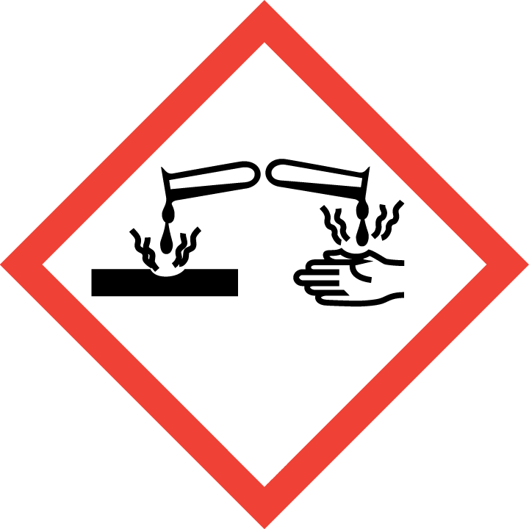

Hazard pictograms :



Signal word : Warning

Hazard statement :

H314- Causes severe skin burns and eye damage.

H319-Causes serious eye irritation

H290-May be corrosive to metals

Precautionary statement:

Prevention :

P234- Keep only in original container.

P264-Wash face, hands and any exposed thoroughly after handling.

P270-Do no eat, drink or smoke when using this product.

P271-Use only outdoors or in a well-ventilated area.

P210 Keep away from heat/sparks/open flames/hot surfaces. - No smoking.

P280- Wear protective gloves/protective clothing/eye protection/face protection.

Response:

P310-Immediately call a POISON CENTER or doctor/physician.

P304+P340+P310: IF INHALED Remove victim to fresh air and keep at rest in a position comfortable for breathing. Immediately call a POISON CENTER or doctor/physician.

P303+P361+P363: IF ON SKIN (or hair) Remove/Take off immediately all contaminated clothing. Rinse skin with water/shower.Wash contaminated clothing before reuse.

P305+P351+P338: IF IN EYES Rinse cautiously with water for several minutes. Remove contact lenses, if present and easy to do. Continue rinsing.

P390- Absorb spillage to prevent material damage.

Storage :

P403+P223: Store in a well-ventilated place. Keep container tightly closed..

P405- Store locked up.

Disposal :

P501- Disposal of contents / container in accordance with national

regulations.

**2.3. Other hazards**

None known

**3. Composition/information on ingredients**

**3.1. Substance**

**-**

**3.2. Mixture**

Information on ingredients / Hazardous components

|  |  |  |  |
| --- | --- | --- | --- |
| Chemical Name | CAS-No | Concentration (%) | Classification GHS |
| Urea | 57-13-6 | 3 |  |
| 1-Hydroxy Ethylidene-1,1-Diphosphonic Acid HEDP | 1-Hydroxy  Ethylidene-1,1-  Diphosphonic  Acid HEDP)  (58-62%)  2809-21-4 | 2 | Causes serious eye irritation 2,H-319. May be corrosive to metals 1, H-290 |
| Sodium Gluconate | 527-07-1 | 7 |  |
| Sodium hydroxide | 1310-73-2 | 0.5 | Causes serious eye damage/ skins burn 1, H-314, May be corrosive to metals 1, H-290 |
| Water | 7732-18-5 | 87.5 |  |

**4. First aid measures**

**4.1. Description of first aid measures**

General advice : If medical advice is needed, provide SDS document to physician.

Inhalation : Do not use mouth-to-mouth method if victim ingested or inhaled the substance; give artificial respiration with the aid of a pocket mask equipped with a one-way valve or other proper respiratory medical device. Move to fresh air. Immediate medical attention is required. If not breathing, give artificial respiration.

Skin contact: :After contact with skin, wash with plenty of water at least 15 minutes. Get medical advice/ attention.

Remove contaminated clothing, shoes and leather accessories.

Eye contact : Rinse cautiously with plenty of water. Get medical advice/ attention.

Ingestion : Do not induce vomiting. In case of swallowing, rinse mouth, drink plenty of water. If feel unwell, seek medical advice.

**4.2. Most important symptoms and effects, both acute and delayed**

Breathing difficulties. Causes burns by all exposure routes. Symptoms of overexposure may be headache, dizziness, tiredness, nausea and vomiting: Product is a corrosive material. Use of gastric lavage or emesis is contraindicated. Possible perforation of stomach or esophagus should be investigated: Ingestion causes severe swelling, severe damage to the delicate tissue and danger of perforation

**4.3. Indication of any immediate medical attention and special treatment needed**

Treat symptomatically

Immediate/Special Treatment: Eye wash stations should be available

**5. Fire-fighting measures**

**5.1. Extinguishing media**

Suitable extinguishing media : fine water spray, foam, dry powder, CO 2

**5.2. Special hazards arising from the substance or mixture**

In the event of fire the following can be released: carbon monoxide, carbon dioxide, sodium oxides

**5.3. Advice for firefighters**

On burning, fire fighter should wear self-contained breathing apparatus if risk of exposure to

product of combustion.

**6. Accidental release measures**

**6.1. Personal precautions, protective equipment and emergency procedures**

Use personal protective equipment. Do not touch or walk through spilled material.

**6.2. Environmental precautions**

Do not discharge into drains or river

**6.3. Methods and material for containment and cleaning up**

Clean-Up Procedures: Collect as much as possible for use or disposal in a properly labeled container. Flush remainder into normal drainage with copious amounts of water.

**7. Handling and storage**

**7.1. Precautions for safe handling**

Advice on safe : wear protective equipment when working. Ensure there is

handling sufficient ventilation in the area. Avoid generating dust.

Hygiene measures : Do not eat, drink or smoke when working. Wash hands before

breaks and after work.

General protective : Do not inhale gases/ vapours/ aerosols. Avoid contact with eyes and

measures skin.

**7.2. Condition for safe storage, including any incompatibilities**

**Prevention of fire and explosion**

Information : no special measures required.

**Storage**

Information : none

Further Information on storage conditions:

Keep container tightly closed and store in a cool, dry well- ventilated location.Store away from heat, flames, ignition sources and incompatibles, keep away from direct sunlight. Avoid contact with water and humidity. . Check regularly for leaks. Store locked up.

**8. Exposure controls / Personal protection**

**8.1. Control parameters**

Exposure limit(s)

**8.2. Exposure controls**

Appropriate : operate in well- ventilated area.

engineering controls

Personal protective equipment

Eye protection : wear safety goggles.

Hand protection : protective gloves.

Body protection : protective working clothes and safety shoes.

Respiratory : wear respirator

protection

**9. Physical and chemical properties**

**9.1. Information on basic physical and chemical properties**

Physical state or appearance: liquid.

Color : colorless.

Odor : Mild

Odor Threshold : no data available.

pH of 1% liquid (25°c) : 5.5-7.5

Melting point : no data available.

Boiling point : no data available.

Flash point : no data available

Evaporation rate : no data available.

Flammability : no data available.

Upper Explosion/Ignition limit: no data available.

Lower explosion limit : no data available.

Vapour pressure : no data available.

Relative vapuor : no data available.

Relative density : no data available.

Solubility : soluble in water.

Partition coefficient : no data available.

(n-octanol/water)

Autoignition : no data available.

temperature

Thermal : no data available.

decomposition

Viscosity, kinematic : no data available.

Viscosity, Dynamic : no data available.

Oxidizing properties : no data available.

**9.2. Other Information**

Density : no data available

Metal corrosion : no data available.

**10. Stability and reactivity**

**10.1. Reactivity**

Vapour/air – mixtures are explosive at intense warming.

**10.2. Chemical stability**

Strong reducing agent. Fire and explosion risk in contact with oxidizing agents. Hygroscopic. heat sensitive. Decomposes to water and carbon dioxide..

**10.3. Possibility of hazardous reactions**

Risk of explosion with: peroxi compounds, perchloric acid, fuming sulfuric acid, phosphorus halides, hydrogen peroxide, chromium(VI) oxide, potassium permanganate, Peroxides, Strong oxidizing agents

Risk of ignition or formation of inflammable gases or vapours with: Iron, Zinc, magnesium, Mild steel

Possible formation of: Hydrogen

Violent reactions possible with: strong alkalis, Aldehydes, alkali hydroxides, nonmetallic halides, ethanolamine, Acetaldehyde, Alcohols, halogen-halogen compounds, chlorosulfonic acid, chromosulfuric acid, Potassium hydroxide, Nitric acid

**10.4 Conditions to avoid**

Incompatible products. Excess heat. Keep away from open flames, hot surfaces and sources of ignition. Exposure to moist air or water..

**10.5. Incompatible materials**

Avoid contact with strong acids and oxidizing agents

**10.6 Hazardous decomposition products**

No dangerous decomposition products known.

**11. Toxicological information**

**11.1. Information on toxicological effects**

Acute toxicity (oral) : not classified.

Acute toxicity : not classified.

(inhalation)

Acute toxicity (dermal) : not classified.

Irritation/corrosion : Causes severe skin burns.

of the skin

Serious eye damage/ : Causes eye damage.

eye irritation

Repeated dose toxicity :. not classified

**CMR assessment**

Carcinogenicity : not classified.

Mutagenicity : not classified.

Teratogenicity : not classified.

Toxicity to reproduction: not classified.

Specific Target Organ : not classified.

Toxicity-single exposure

Specific Target Organ : not classified.

Toxicity-Repeated exposure

Aspiration hazard : not classified.

**12. Ecological information**

**Ecotoxicology Assessment**

Acute aquatic toxicity: not classified..

**12.1. Ecotoxicity**

No data available.

**12.2. Persistence and degradability**

No data available

**12.3. Bioaccumulative potential**

No data available.

**12.4. Mobility in soil**

Soluble in water.

**12.5. Other adverse effects**

Discharge into the environment must be avoided

**13. Disposal considerations**

**13.1 Waste treatment methods**

Waste from residue: Disposal should be in accordance with local regulations and legislation.

Contaminated packaging: Dispose of empty contaminated containers in accordance with

regulations and legislation.

**14. Transport information**

Not classified as dangerous goods for transport

**D.O.T Road/Rail**

UN number : not applicable.

UN proper shipping name: not applicable.

Hazard label: not applicable.

Transport hazard class (es): not applicable.

. Packing group : not applicable.

Transport in bulk : not applicable.

. Special precaution for user: not applicable.

**Air transport ICAO-TI/IATA-DGR**

. UN number : not applicable.

UN proper shipping name: not applicable.

Transport hazard class(es): not applicable.

Packing group : not applicable.

Transport in bulk : not applicable.

. Special precaution for user: not applicable.

**Sea transport IMDG**

UN number : not applicable.

UN proper shipping name: not applicable.

Hazard label: not applicable.

Transport hazard class(es): not applicable.

Packing group : not applicable.

Environmental hazards (Marine pollutant): yes

Transport in bulk : not applicable.

Special precaution for user: not applicable.

**15. Regulatory information**

**15.1 Safety, health and environmental regulations/ legislation specific for the**

**substance or mixture.**

* Regulation on classification and labeling of chemicals - Number 04/2012/TT-BCT - Date issued :13/02/2012
* Regulations on the list of hazardous industrial goods to be packed in the process of transporting and transporting dangerous industrial goods by road, rail and inland waterway transport - number: 44/2012/TT-BCT - Date issued 28/12/2012
* National technical standard for ambient air quality - QCVN05:2013/BTNMT
* National technical regulation on some hazardous substances in the surrounding air - QCVN06:2009/BTNMT
* Decision, No.3733/2002/QD-BYT.

**16. Other information**

The information in the sheet were written based on the best knowledge and experience

currently available but without liability.

SDS prepared on: December 14, 2020

Revision date :December 18, 2020

Version 1.0

Legend

TWA: Time Weighted Average.

STEL: Short term exposure limit.

IATA: International Air Transport Association

ICAO: International Civil Aviation Organization

IMDG: International Maritime Dangerous Goods

ACGIH:American Conference of Governmental Industrial Hygienists

Skin corrosion/irritation, 1A : Skin corrosion/irritation , Hazard Category 1A.

Serious Eye Damage/Eye Irritation,1 : Serious Eye Damage/Eye Irritation, Hazard Category 1

Metal corrosive,1 : Metal corrosive, Hazard Category 1

H314- Causes severe skin burns and eye damage.

H319-Causes serious eye irritation

H290-May be corrosive to metals